**worksheet 34: BuildHeap and Heap Sort Name: GROUP 11**

**Worksheet 34: BuildHeap and Heap Sort**

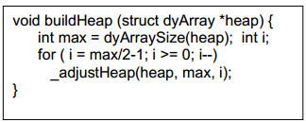**In preparation**: If you have not done so already, you should complete Worksheet 33 to learn more about the heap data structure.

In some applications it is useful to initialize a Heap with an existing vector of values. The values are not assumed to be organized into a heap, and so a routine named buildHeap is invoked for this purpose.

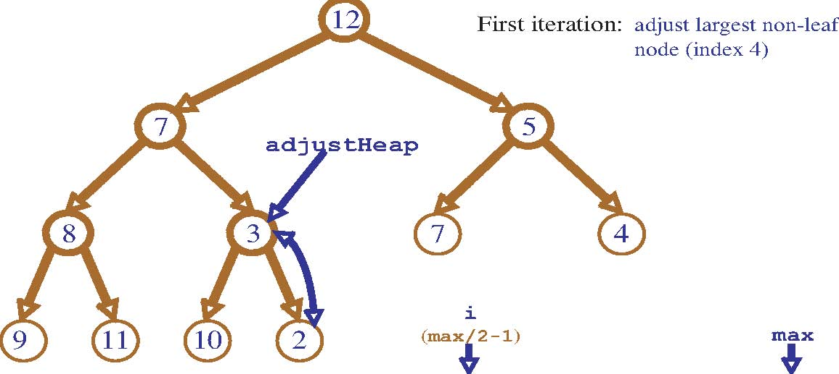

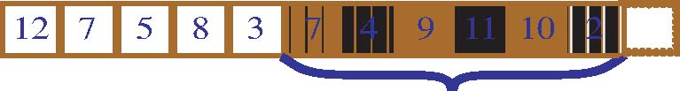



All values indexed after max/2 are leaves, and are therefore already a heap. The first value that could potentially not be a heap is found at max/2. Walking backwards from this value until the root is reached eventually makes all nodes into a heap.

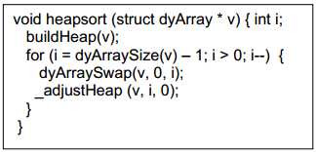The heap data structure provides an elegant technique for sorting a vector. First form the vector into a heap. To sort the vector, the top of the heap (the smallest element) is swapped with the last element, and the size of the heap is reduced by 1 and readjusted. Repeat until all elements have been processed.

worksheet 34: BuildHeap and Heap Sort Name:

Simulate execution of the Heap sort algorithm on the following values:

9 3 2 4 5 7 8 6 1 0

First make the values into a heap (the graphical representation is probably easier to work with than the vector form). Then repeatedly remove the smallest value, and rebuild the heap.

**Build**

9 9 9 9

3 2 3 2 3 2 3 2

4 5 7 8 4 0 7 8 1 0 7 8 1 0 7 8

6 1 0 6 1 5 6 4 5 6 4 5

9 0 0 0

0 2 9 2 1 2 1 2

1 3 7 8 1 3 7 8 9 3 7 8 4 3 7 8

6 4 5 6 4 5 6 4 5 6 9 5

|  |  |  |  |  |  |  |  |  |  |
| --- | --- | --- | --- | --- | --- | --- | --- | --- | --- |
| 0 | 1 | 2 | 4 | 3 | 7 | 8 | 6 | 9 | 5 |

**Sort**

0 5 1

1 2 swap 1 2 adjust 3 2

4 3 7 8 4 3 7 8 4 5 7 8

6 9 5 6 9 0 6 9 0

9 2 6

swap 3 2 adjust 3 7 swap 3 7

4 5 7 8 4 5 9 8 4 5 9 8

6 1 0 6 1 0 2 1 0

3 8 4

adjust 4 7 swap 4 7 adjust 5 7

6 5 9 8 6 8 9 3 6 8 9 3

2 1 0 2 1 0 2 1 0

9 5 8

swap 5 7 adjust 6 7 swap 6 7

6 8 4 3 9 8 4 3 9 5 4 3

2 1 0 2 1 0 2 1 0

6 9 7

adjust 8 7 swap 8 7 adjust 8 9

9 5 4 3 6 5 4 3 6 5 4 3

2 1 0 2 1 0 2 1 0

8 8 9

swap 8 7 adjust 9 7 swap 8 7

6 5 4 3 6 5 4 3 6 5 4 3

2 1 0 2 1 0 2 1 0

|  |  |  |  |  |  |  |  |  |  |
| --- | --- | --- | --- | --- | --- | --- | --- | --- | --- |
| 9 | 8 | 7 | 6 | 5 | 4 | 3 | 2 | 1 | 0 |